Notify #766723
UC/Synergetic Design
P.O. Box #550
Cottage Grove, MN 55016
(612)-991-7267
RE: MCImetro Access Transmission Services Corp., Facility Attachment Asset Permit Application APA8429, in St. Paul, MN.
Xcel Energy Facility Attachments
825 Rice St.
St. Paul, MN 55117

I have completed the site inspection and technical review of MCImetro Access Transmission Services Corp. application, permit number APA8429. I have determined that all poles as indicated on the sketch can be attached to without any rearrangements or pole change-outs with the exception of the poles listed below. This determination was made by referencing the requirements for communications attachments found in the “Xcel Energy Electric Distribution Design and Construction Standards” manual.
It is the attaching utilities responsibility to make sure that all NESC and local ordinances for vertical clearance above surfaces (roads, alleys, fields, buildings etc.) are met.

Note!
Total count of poles checked = 63. 30 – New Attachments
30 poles are owned by Xcel Energy. 33\* poles are foreign owned.\* Total of 30 Xcel Energy poles can be attached to on this request.
Measurements were taken on February 2 with an ambient temperature of +14° F.
Poles of concern needing some sort of modification to meet clearance requirements are as follows:
See notes in Xcel Energy Use Only columns of the Attachment Information sheet.
Please note: Attachments must be tagged for communication ownership on every pole. Upon completion of project, Xcel Energy must be notified to complete a post inspection.
Estimated costs for any required “make-ready” work will be provided by Xcel Energy Design Staff upon request. Attachments cannot be made until the cost estimate is approved, payment is made, and the requesting party is notified by Xcel Energy that the “make-ready” work has been completed in the field.
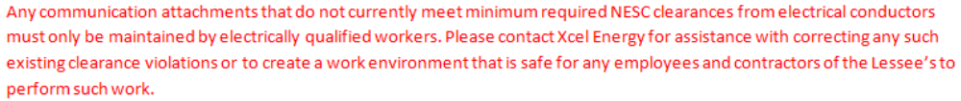
Sincerely,
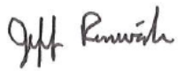
Jeff Renwick
Joint Use Technician
UC/Synergetic Design Inc.

